Tufts Robotic Sailing Information Sheet—Sailbot Competition

**Boat Specifications:**

* Length: max 2 m (sensors not included)
* Beam: max 3 m with zero heel
* Draft: max 1.5 m in normal sailing coniditions
* Height: max 5 m (sensors not included)

**Other Rules:**

* Need a stand to support the boat
* No direct human contact
* Need full remote radio at all times during competition to avoid collisions
* Data transfer to shore is unlimited, must be at an approved frequency
* Any material can be used
* Bilge pumps are permitted
* Sail configuration changes can occur during the race but only by an onboard system

**Competitions:**

* Fleet race:
  + Group of boats sail between two buoys and around two other bouys
  + Use remote control for steering and autonomous sails
  + Fastest boat gets 10 points

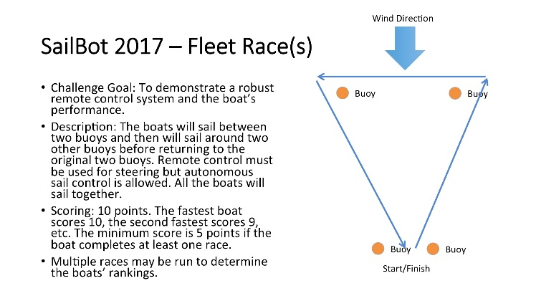

* Station Keeping
  + Boat autonomously stays in 40x40 m box for 5 minutes
  + Exits within 30 seconds
  + Can leave and return the box but there are point deductions

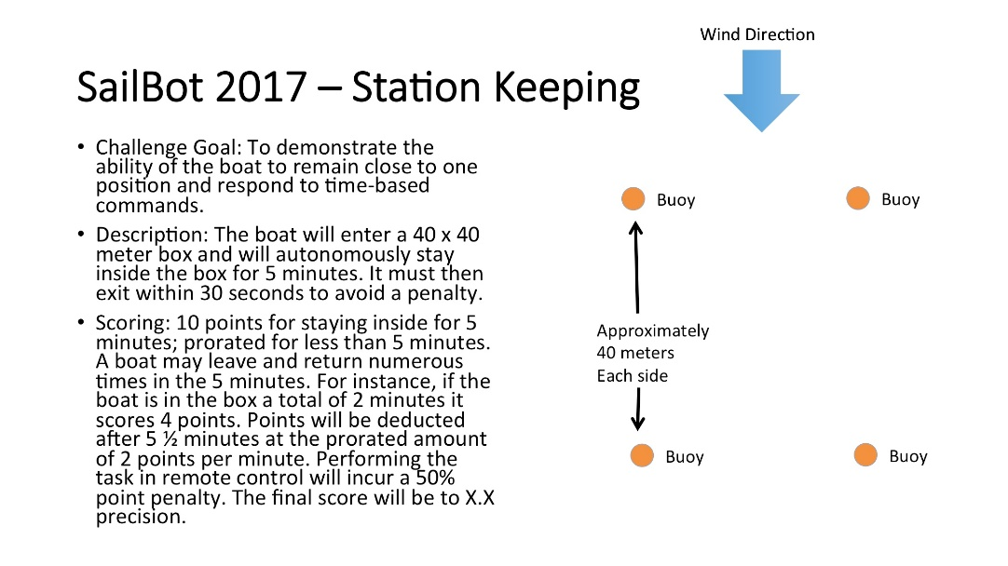

* Precision Navigation
  + Autonomously sail around 2 buoys, start and end through a start/finish line

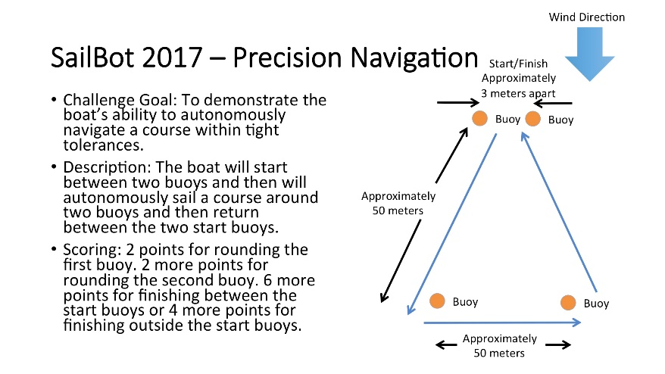

* Payload
  + Start between two buoys, sail around a buoy ad back
  + Remote or autonomous
  + Boat carries cargo, scoring is based on the percentage of the boat’s empty weight that the cargo represents

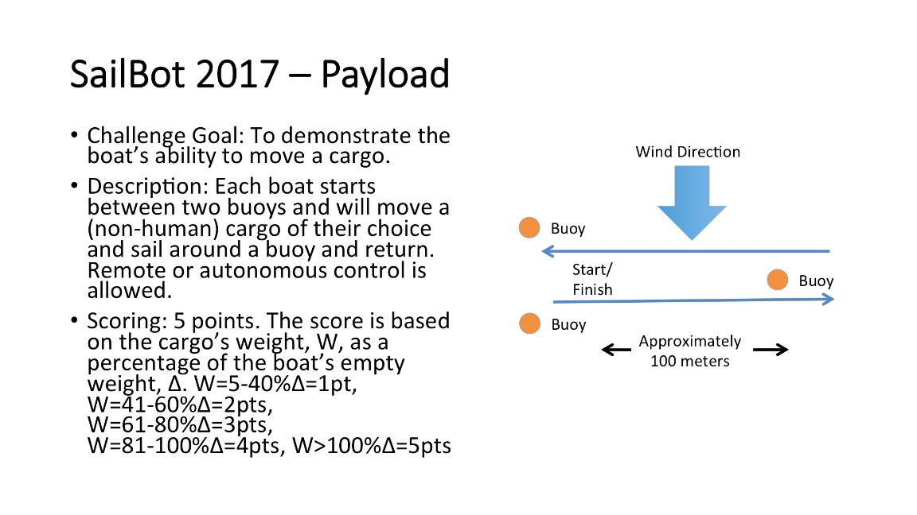

* Collision Avoidance
  + Start between 2 buoys, round a buoy and return
  + Sail autonomously on a reach
  + Must avoid a collision

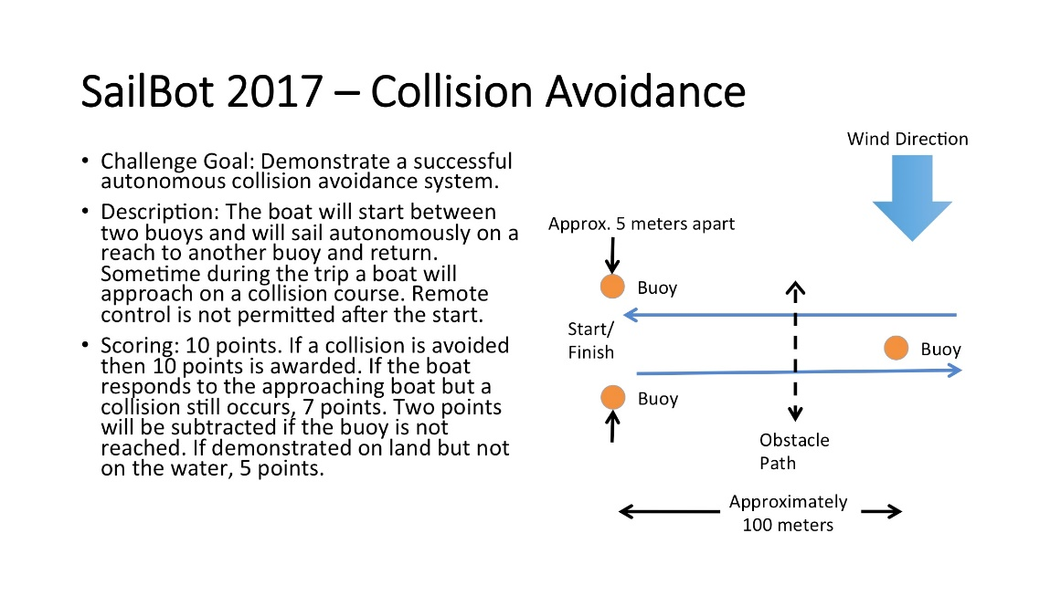

* Search
  + Small buoy placed within 100 m of starting position
  + Boat locates and touches buoy within 5 mins
  + Boat must indicate it found the buoy with flashing white strobe light or signal to shore station

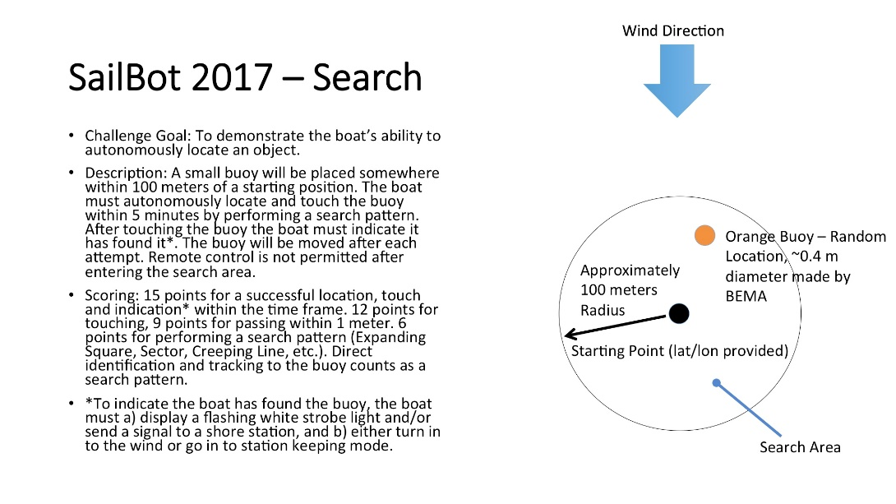

* Long Distance Race
  + Sail around 4 buoys for up to 8 hours
  + 1 pt for each lap
  + Must be within 10 m of each buoy
  + Remote control is allowed but there is 50 percent deduction
  + Additional pt for each extra hour sailed with no pitstop

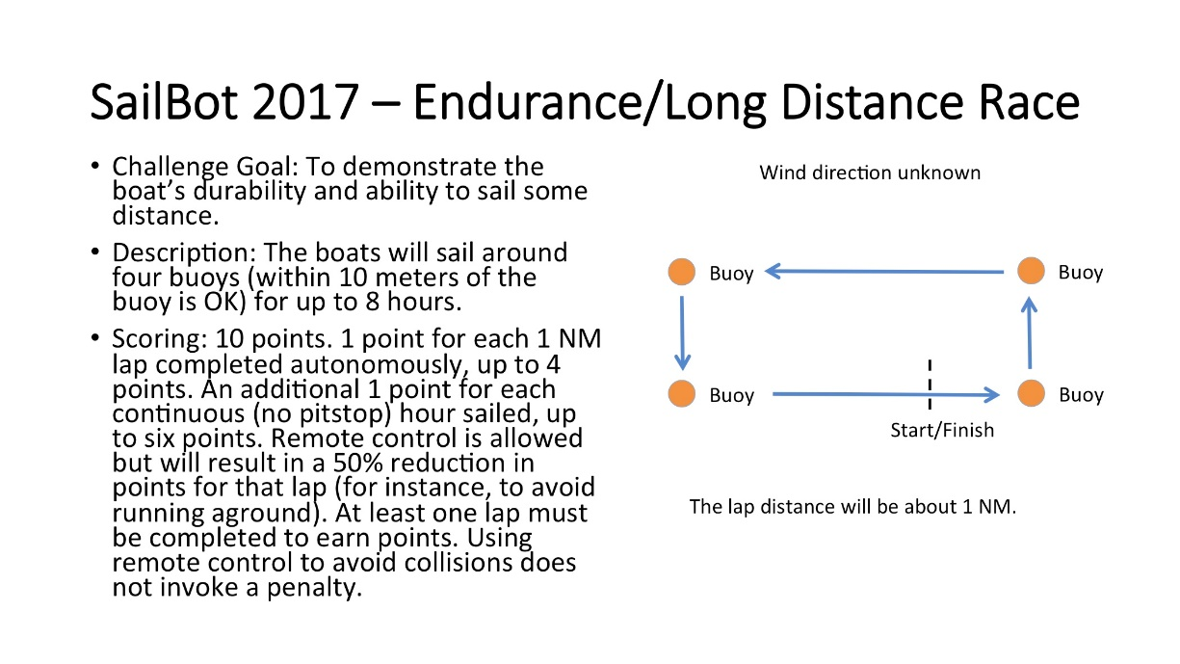

* Presentation
  + Topics: workmanship, innovation, control theory, boat design, student involvement
  + Each team presents to panel of experts in area of control theory, systems engineering, and naval architecture
  + 20 minute presentation, 10 minute Q&A

Tufts Robotics Sailing Technical Planning

**What other teams do well:**

**How to receive data on laptop:**